[Header: SaNDAI Global - Empower the Future Workforce]

[Image: Diverse group of high school students engaged in virtual learning]

DataGen Scholars Program: Transforming Futures with Tech

Unlock the potential of tomorrow's workforce by supporting the DataGen Scholars Program—a groundbreaking initiative designed to improve diversity in tech by preparing high school students from disadvantaged and underrepresented communities for the jobs of the future.

What is DataGen Scholars?
DataGen Scholars is a 12-month virtual program that empowers students with essential skills in data analytics and generative AI. This program levels the playing field, providing opportunities for students to excel in a data-driven world. Our goal for this year is to enroll 150+ high school students from disadvantaged communities across DC, Maryland, and Virginia, with 85 students already enrolled. In 2025, we aim to enroll 50 disadvantaged high school students in every state.

Why Support DataGen Scholars?
Bridge the Digital Divide: Provide access to technology education to students who often lack tech coursework.
Empower with Tech Skills: Equip students with essential data analytics and generative AI skills.
Build a More Inclusive Community: Foster tech literacy among youth, shaping a diverse and innovative workforce.

Program Components:
1. Self-guided Training: Students complete 12 DataCamp eLearning courses relating to data analytics
2. Group Training: Students complete 24 SaNDAI-created courses relating to data analytics and generative AI
3. Micro-job: Students receive paid hands-on experience for real-world application
4. Industry Certification: Students obtain a Data Analyst, Data Scientist, or Data Engineer certification

Benefits for Participants:
- Gain real-world work experience while in high school
- Earn up to $8,000 during the program
- Enhance professional backgrounds and LinkedIn profiles
- Unlock increased job opportunities post-high school

Program Timeline:
- Commenced on January 1st, 2024
- Ends on December 31st, 2024
- New programming starts each month as students enroll

Accessibility:
All activities are held virtually, accessible via phone, tablet, or computer.

How You Can Make a Difference:
If you are a corporate, business, or government agency leader, you can contribute by:
1. Providing small paid projects during the micro-job phase.
2. Offering internships to participants at the program's end.
3. Spreading the word about this partnership opportunity within your networks.

Claudette Keen
Senior Manager of Training Programs

571-799-5965
claudette@sandaiglobal.com

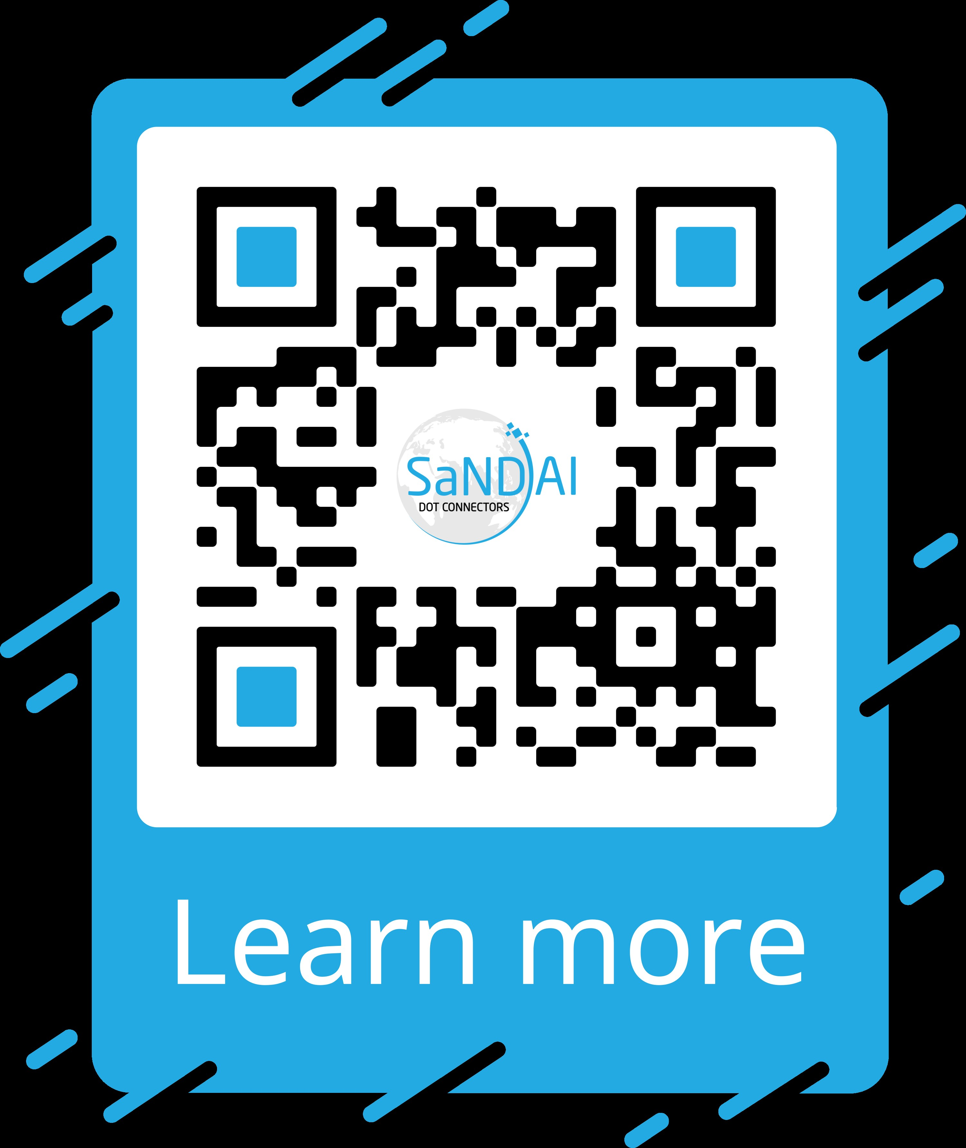

Unlock the potential of tomorrow's workforce by supporting the DataGen Scholars Program!

[Footer: SaNDAI Global Logo]

[Background: Imagery of high-tech workspace, students collaborating virtually, and vibrant tech graphics]

